Civil war in Somalia

UNSC Resolution: | 814
Date of adoption: | 26-Mar-1993
Operative paragraph: | 8
Demand number: | 814,0811

Sarah-Myriam Martin-Brûlé

Wording of demand

comply fully with the commitments undertaken in the agreements concluded at the Informal Preparatory Meeting on Somali Political Reconciliation in Addis Ababa, and in particular with the Agreement on Implementing the Cease-fire and on Modalities of Disarmament (S/25168, annex III)

List of addressees of the demand
- Government of Somalia, United Somali Congress Faction

Short-term compliance

Description of the addressee(s)’ conduct

“18. In the Agreement (sect. I, Disarmament and Security), the Somali political leaders committed themselves "to complete, and simultaneous disarmament throughout the entire country in accordance with the disarmament concept and time-frame set by the Cease-Fire Agreement of January 1993". 10/

19. The expert therefore deplores the fact that despite several calls from the Security Council 11/ for a comprehensive and effective programme for disarming of the Somali parties, including movements and factions, the Somali leaders continue to violate the commitments they made on 27 March and 1 October 1993, notwithstanding their request to UNOSOM to apply strong and effective sanctions against those responsible for any violation of the Cease-Fire Agreement. Furthermore, the Somali leaders have reiterated that to find a genuine and lasting solution to the Somalia crisis, the cooperation of UNOSOM II with the political organizations and community leaders is essential for the fulfilment of the Addis Ababa Peace Agreement.

United Nations Report by the independent expert on the conditions in Somalia E/CN.4/1994/77/

“ Aidid’s aggressive anti-UNOSOM II actions increased after the departure of a majority of the American forces.”
(…)
“On May 6, two days after the official UNITAF turnover to UNOSOM II, Aidid’s warlord ally Jess and his militia, who had been ousted from Kismayo in February, launched a new attack on the city in an effort to wrest control from clans loyal to the pro-Barre warlord Morgan. It was an egregious violation of the cease-fire agreement hammered out several weeks before in Addis Ababa.”
(…)

“Aidid used the Somali distrust of foreigners in order to rally Somali support to fight and resist UNOSOM II forces”
(…)

“the anti-UNOSOM II radio diatribes accused the UN of interference in the internal affairs of the Somalia, and accused UN military forces of murder, rape, and pillage against Somali citizens. In the US opinion, these radio broadcasts contravened the spirit and letter of the Addis Ababa agreement.
(…)
“Pakistani troops inspected the radio station an were attacked by Aidid loyalists. (…) Twenty four Pakistanis were killed and more than fifty-five injured. (…)six Pakistani soldiers were taken prisoner. One of them was killed in Somali captivity, and the five others were released to UNOSOM II officials (…).

Kenneth R. Rutherford. 2008. Humanitarianism Under Fire: The US and UN Intervention in Somalia. Kumarian Press. P. 126- 129.

“Starvation had practically ceased but organized thievery was increasing and basic
services like water and electricity still had not been restored in most cities and towns. No significant steps had been taken toward a national police force, but auxiliary police forces now totaled over five thousand. On 29 March, meeting again at Addis Ababa, representatives from fifteen Somali factions agreed that a transitional national council would act as the country’s principal political authority. The council would work with relief agencies and with UNOSOM II to carry out humanitarian assistance programs as well as cease-fire and disarmament accords. However, disarmament agreements had not been widely carried out, and none of the warlords showed willingness to compromise or negotiate in good faith.”

Poole.W. 2005. The Effort to Save Somalia: August 1992- March 1994.
http://www.dtic.mil/doctrine/jel/history/somalia.pdf

Assessment

Short-term compliance
X No or marginal compliance (1) | Medium low compliance (2) | Medium high compliance (3) | Full or almost full compliance (4)

Considerations underlying the assessment

Within the six months following the adoption of the resolution, the demand addressees did not comply fully with the commitments undertaken in the agreements concluded at the Informal Preparatory Meeting on Somali Political Reconciliation in Addis Ababa, and in particular with the Agreement on Implementing the Cease-fire and on Modalities of Disarmament (S/25168, annex III).

Medium-term compliance

Description of the addressee(s)’ conduct

“(...) The expert therefore deplores the fact that despite several calls from the Security Council 11/ for a comprehensive and effective programme for disarming of the Somali parties, including movements and factions, the Somali leaders continue to violate the commitments they made on 27 March and 1 October 1993, notwithstanding their request to UNOSOM to apply strong and effective sanctions against those responsible for any violation of the Cease-Fire Agreement. Furthermore, the Somali leaders have reiterated that to find a genuine and lasting solution to the Somalia crisis, the cooperation of UNOSOM II with the political organizations and community leaders is essential for the fulfilment of the Addis Ababa Peace Agreement.

(…) The expert therefore deplores the fact that despite several calls from the Security Council / Security Council resolutions 814 (1993) of 26 March 1993, para. 8; 837 (1993) of 6 June 1993, para. 3 and 865 (1993) of 22 September 1993, eleventh preambular paragraph./ for a comprehensive and effective programme for disarming of the Somali parties, including movements and factions, the Somali leaders continue to violate the commitments they made on 27 March and 1 October 1993, notwithstanding their request to UNOSOM to apply strong and effective sanctions against those responsible for any violation of the Cease-Fire Agreement. Furthermore, the Somali leaders have reiterated that to find a genuine and lasting solution to the Somalia crisis, the cooperation of UNOSOM II with the political organizations and community leaders is essential for the fulfilment of the Addis Ababa Peace Agreement

(...) 10. Although General Aidid declared a cease-fire on 9 October 1993, he was subsequently quoted as having stated in an interview that the presence of UNOSOM troops was undesirable and had become an obstacle to any political solution in Somalia. 4/ This statement was made in spite of ongoing efforts by senior United Nations officials, including a visit by the Secretary-General to Somalia on 22 October 1993, aimed at achieving implementation of the Addis Ababa Agreement. Later on, it was reported that the cease-fire had broken down and that clan feuding had started up again in Mogadishu.

ADVISORY SERVICES IN THE FIELD OF HUMAN RIGHTS
Report by the independent expert, Mr. Fanuel Jarirentundu Kozonguizi, on the conditions in Somalia, prepared in accordance with paragraph 6 of Commission on Human Rights resolution 1993/86, Fiftieth session Doc. No. E/CN.4/1994/77, Item 19 of the provisional agenda 15 December 1993
http://daccessdds.un.org/doc/UNDOC/GEN/G93/858/62/PDF/G9385862.pdf?OpenElement

Assessment

Medium-term compliance
X No or marginal compliance (1) | Medium low compliance (2) | Medium high compliance (3) | Full or almost full compliance (4)

Considerations underlying the assessment

Within the two years following the adoption of the resolution, the demand addressees did not comply fully with the commitments undertaken in the agreements concluded at the Informal Preparatory Meeting on Somali Political Reconciliation in Addis Ababa, and in particular with the Agreement on Implementing the Cease-fire and on Modalities of Disarmament (S/25168, annex III).

Depth of demand

Assessment

Level of depth of demand
Low depth of demand (1) | Medium depth of demand (2) | X High depth of demand (3)

Considerations underlying the assessment

“Aidid’s suspicions that Boutros-Ghali’s intentions in Somalia were to undermine his pursuit of the Somali presidency.”
(…)
“Aidid saw UNOSOM II as a threat to his survival because he didn’t have the votes under its proposed formula for selecting judges.”

Kenneth Rutherford. 2008. Humanitarianism Under Fire: The US and UN Intervention in Somalia. Kumarian Press, p.128.

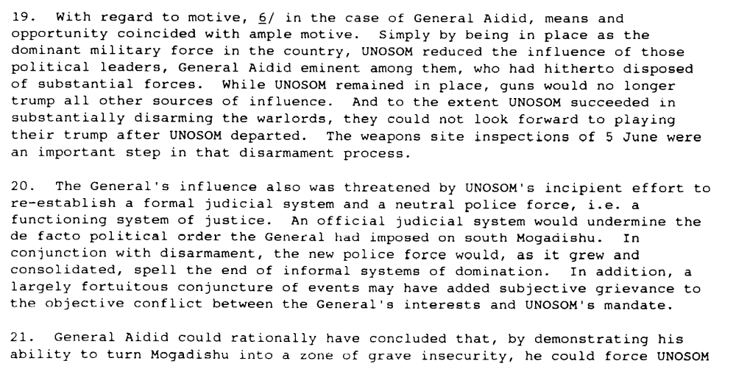

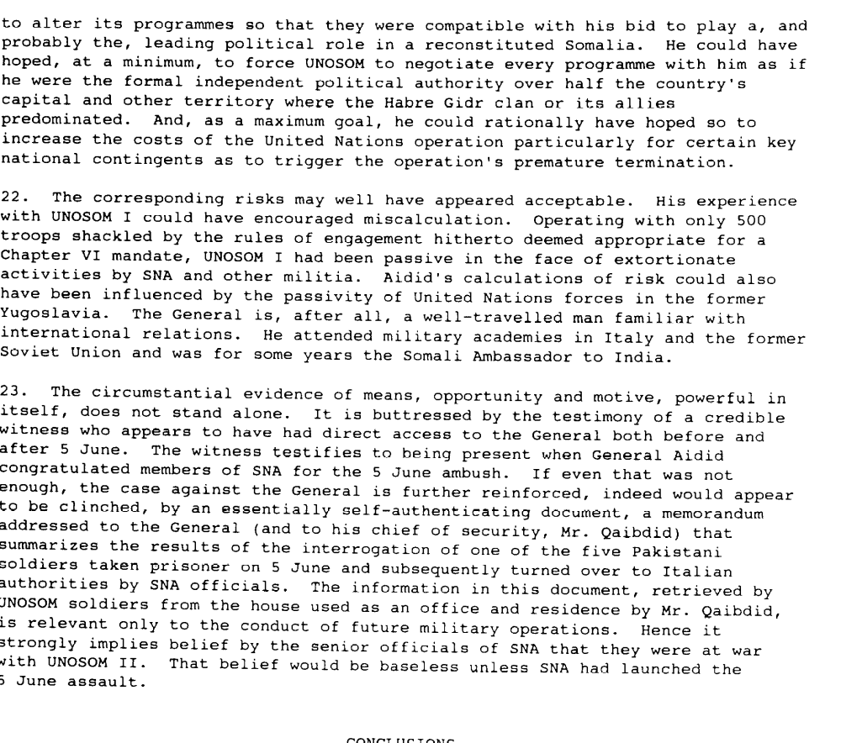

Report Pursuant to Paragraph 5 of Security Council Resolution 837 (1993) on the investigation into the 5 June 1993 attack on United Nations Forces in Somalia conducted on behalf of the secretary-general, 24 August 1993, S/26351

“Mohammed Farah Aideed evidently worried that the “bottom up” strategy would undercut his power.”

Walter Poole. “The Efforts to Save Somalia: March 1992-August 1994”
http://www.dtic.mil/doctrine/jel/history/somalia.pdf

Level of confidence about coding decisions

Level of confidence about coding decision
Extremely high | X High | Moderate

Comments to IPI (if any)

